SeisMac Activity II: How “hard” does an Earthquake shake?
Michael Hubenthal, hubenth@iris.edu Version 1.0 – July 13, 2007

Prior Knowledge
Students should know how to interpret a three-component seismogram and have received a basic introduction to SeisMac from Activity 1: “Take the pulse of your classroom using SeisMac!”

Guiding Question(s):
- How hard does the Earth shake during an earthquake?
- What does an accelerometer measure? How can it be used to measure an earthquake?
- What is an earthquakes intensity?
- How is an earthquakes intensity measured?

Materials
- Download video clips; Kitchen/Office (5.3MB) and Child’s Bedroom (4.1MB) from http://www.abag.ca.gov/bayarea/eqmaps/fixit/videos.html
- Print three copies of the CNN news transcript at the end of this document
- Video projector connected to a Mac laptop running SeisMac
- Table set up with non-breakable items (cups, picture frame, stack of books.)
- Print copies of Ground acceleration handout.

Preparation
- If you haven’t already done so, download and run the SeisMac calibration software (It is simple and takes about 2 minutes to complete!) http://www.suitable.com/tools/seismacalibrate.html

Lesson Description: Quick Summary
OPERA | Time (min)
Open | 5
Prior knowledge | 10
Explore/Explain | 10
Reflect | 20
Apply | 20
Total Time Estimate | 65

Teacher Instructions (w/ Potential Questioning Sequences)

Open – 5 Minutes
Handout copy of CNN news script to two volunteers; one boy and one girl (CNN, 2001).

and/or show the Child’s Bedroom video clip from http://www.abag.ca.gov/bayarea/eqmaps/fixit/videos.html

Prior Knowledge – 10 Minutes

Taxonomy | Question | Answer
Knowledge | Has anyone here ever experienced an Earthquake? If so, please describe the experience. | Show of hands – then, if any have, ask a student or two to share their experience.
Comprehension | Explain how “hard” do you think an Earthquake shakes? | Answers will vary, but a discussion of the relative nature of terms like shaking could be timely and could be tied to the next question.
Application | Ask several students to model the amount of shaking described by their classmates with their notebooks?
Analysis | How could we determine how accurate the student demos of shaking were? What would we need to test out whether their or not their shaking was accurate? | Answers should include… something to measure the amount of shaking they generated when shaking their book, like SeisMac and measures of actual shaking during an earthquake for comparison

Explore/explain – 10 Minutes

Instructor Demonstration
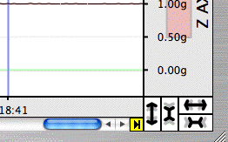
- Start up SeisMac and note to students that before we can use SeisMac to measure how the students shook their notebooks we need to make sure we understand all of the information SeisMac displays.
- Adjust the vertical scale for the horizontal components (X and Y axis) so that the display shows values from -1.00 to 1.00g.
- After reviewing why SeisMac displays the three graphs, have the students note the baseline values of each of the X,Y,Z components while the laptop is sitting normally on a table. Note: When the laptop is oriented normally, the baseline of the vertical component is 1.00g and the two horizontal components have baselines of 0.00g. If your laptop does not show these values you should run the SeisMac calibration software described under preparation.
- Tilt the laptop 90° in each of the three directions and note the new baseline values. g. Note: When the laptop is tilted the vertical component reading changes to 0.00g and one of the two horizontal components will change to 1.00g.

Taxonomy | Question | Answer
Knowledge | Describe what happened to the graphs when I tilted the laptop? | When the laptop is oriented normally, the baseline of the vertical component is 1.00g and the two horizontal components have baselines of 0.00g. When the laptop is tilted the vertical component reading changes to 0.00g and one of the two horizontal components will change to 1.00g.
Comprehension | Therefore, what determines what the graph reads? | Position is a likely response.
Application | What directional force is being applied to the laptop that could cause the values to change and read 1.00? | Gravity!
Application | Therefore what does SeisMac measure? | The sensor measures acceleration and is calibrated in units of gravity (g) where 1 g is equal to the acceleration of gravity at the Earth's surface or 9.81m/s².
Application | Now if I shake the laptop lightly, I notice that I can get negative g’s. Can anyone explain how that is that possible? Does it mean that gravity had gone away? | No, the sensors are set with positive measures in one direction and negative in the other.
Application | Okay, so knowing that the sensor is positive in one direction and negative in the other, how would I move the laptop vertically (not tilting it) to get the graph to touch the 0.00g in the Z axis? | Move the laptop suddenly downwards. If you move it quickly enough, you can get –g’s. Then quickly push the yellow pause button to stop the recording. Scroll back in time to see the data of the “fall”. An example image is below.
Optional question and discussion  Analysis | Using a pointer, ask the students to make a connection between the motion they saw and the graph that was recorded by describing what was happening to the laptop at each of the points indicated on the example diagram below; a, b, c, and d. | a = steady state or sitting still  b = accelerating downwards (+ acceleration but in a negative direction)  c = Instant at which it is brought to a stopped position. (The graph shows the force of gravity plus the force necessary, from you to stop the fall.)  d =completely stopped and a return to steady state.

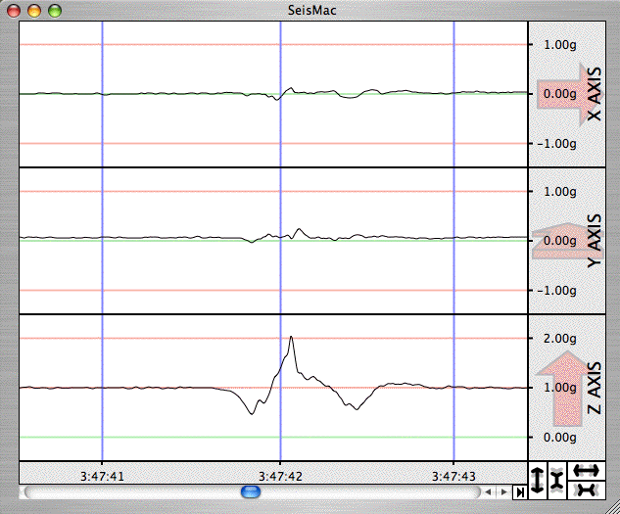

c

a..
b.
d

Reflect – 20 Minutes
Student Demo - Ask a volunteer to come-up and slowly begin shaking the laptop until about 1g maximum in either horizontal direction is reached.

Taxonomy | Question | Answer
Comprehension | Thinking back to how you shook your notebook at the beginning of class wow did that demonstration compare to how hard your shaking was. | Probably not as hard. Students can shake a notebook at around 2.00g

OPTIONAL: To measure how hard the students shook their notebooks adjust the horizontal scale on SeisMac to its maximum, and have a RESPONSIBLE student carefully shake the laptop as vigorously as they safely can, and then stop and click the yellow pause button so the maximum acceleration achieved can be recorded. (A student is likely to be able to shake the laptop to a little over 2.00g)

Taxonomy | Question | Answer
Comprehension | Thinking about your own house, does that amount of shaking seem like it would be enough to cause damage? | Most students will respond that they don’t think it is hard enough.

Instructor Demo
Comprehension | Since we can’t make an earthquake happen right now, how could we test out our ideas? | Accept all answers but lead students to develop and experiment shaking a lab table at various accelerations to see what happens to the materials on top.

1) Next place the laptop on the table set up with non-breakable items.

Comprehension | What do you predict will occur to these items on the table if I shake the table at 0.25g, 0.5g, 1.0g? | Accept all answers

2) Ask another volunteer to come up and shake the table (while holding onto the laptop) at 0.25g and note what happens. Then try 0.5g and 1.0g.

Application | Now applying this new information from our experiment, does 1.0g of acceleration seem like it would be enough to cause damage? | Accept all answers, but lead the discussion to suggest that perhaps we could use information from other experiments (like the video clip from the beginning of class, or an earthquake to better inform our responses)

3) Show the ; Kitchen/Office video clip from http://www.abag.ca.gov/bayarea/eqmaps/fixit/videos.html and tell students that the video clips of the house shaking had a peak acceleration of about 1g at the base.

Note: The video footage shows a two-story house being tested by a simulated earthquake on a shake table at the University of California at San Diego on July 11, 2000. The test examined the effect of very severe ground shaking with very strong construction. The goal was to verify that a new house that conforms to all building code regulations and in addition is specially engineered can escape with little damage from such an earthquake.

4) Show students the images of the Kobe earthquake and note the ground accelerations. During the 1995 Kobe earthquake (M 6.9) peak ground accelerations as large as 0.8 g were recorded in the near-fault region on soil sites in Kobe and Nishinomiya (Somerville, 1995).

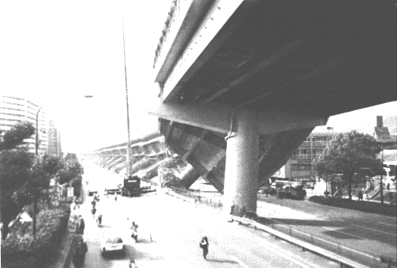
Figure 1: Collapse of the Hanshin Expressway in Nishinomiya. Photograph by Paul Somerville.

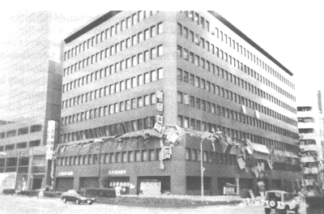
Figure 2: Story collapse in a modern building in the Sannomiya district of downtown Kobe. Photograph by Paul Somerville.

Taxonomy | Question | Answer
Application | Having seen the video clip and the images, now what do you think? | Accept all answers but emphasize the fact that the test building took 1.0g of acceleration without great physical damage and the Kobe photos were only 0.8g.
Analysis | What other factor(s) might affect the amount of damage to a house besides the strength of shaking? | Duration and frequency of shaking, physical construction of the buildings (both quality of construction, and natural frequency*). It should also be noted to students that all buildings are less susceptible to damage from vertical accelerations than they are to horizontal accelerations. This is due to the fact that all buildings must be constructed to withstand the natural 1g in the vertical but >.3g in the horizontal is enough to cause damage even in specially designed structures.

*Note: To explore how the natural frequency of a building can impact the shaking of a building during an earthquake please see…
http://www.iris.edu/edu/bosslite.htm or
Hubenthal, M. (2006) Revisiting the BOSS model to explore building resonance phenomena with students. The Earth Scientist, 22(2), 12-16.

Apply - 20
Taxonomy | Question | Answer
Application | So far we have talked about the maximum shaking in an earthquake. How would you expect shaking to vary in the region around the earthquake? | Expect highest shaking near epicenter, decreasing radially outward, though local geology can significantly modify this pattern
 | Where would you expect to find the most damage from an earthquake? Why? | Accept either where the acceleration is highest or nearest the earthquake. Discuss that sometimes the greatest shaking is on soft soils at a distance from the epicenter.*
 | If you didn't have an accelerometer to measure the shaking in an earthquake, how else could you describe and quantify the shaking at different distances from an earthquake? | Guide the discussion in the direction of measuring earthquake intensity, using descriptions of damage and how the earthquake was felt.

*Note: To explore how soil type can affect how an earthquake is perceived please see the following as an example.
http://www.extension.iastate.edu/e-set/science_is_here/earthquake.html

Distribute student handouts for them to apply what they know about how hard the ground can shake during an earthquake to the concept of Intensity.

Conclude the activity by discussing the answers to the student worksheet and visiting the USGS “Did You Feel It” website to view an intensity map of an earthquake in your local region. http://earthquake.usgs.gov/eqcenter/dyfi.php USGS “Did You Feel It” website is intended to tap the abundant information available about earthquakes from the people who actually experience them. Users can contribute their experience of an earthquake, either immediately afterward, or whenever it is possible for you to do so. This information is then combined and used to generate maps of an earthquakes intensity.
References & Acknowledgements
CNN. 2001. Powerful Earthquake Strikes Japan. Accessed on July 13, 2007 at
http://transcripts.cnn.com/TRANSCRIPTS/0103/24/smn.02.html

Richter, C., Elementary Seismology, WH Freeman, 1958.

Somerville, P. 1995. Kobe Earthquake: An Urban Disaster Eos, 76 (6) pp. 49-51.

USGS. What is intensity? Accessed on July 13, 2007 at http://pasadena.wr.usgs.gov/shake/ak/html/background.html#intensities

Wald, D. J., Quitoriano, V., Heaton, T, H., & Kanamori, H. 1999. Relationships between Peak Ground Acceleration, Peak Ground Velocity and Modified Mercalli Intensity in California. Earthquake Spectra, 15(3), 557-564.

Thanks to David Wald of the USGS for his review and suggestions.
Name ________________________________ Date _____________________

How “hard” does the ground shake during an earthquake?
Student Handout – Page 1
1. What information does this map show us?

2. Even though it isn’t described on the map what do you think the star represents? Use your textbook to find what the “technical” name of this location is?

How “hard” does the ground shake during an earthquake?
Student Handout – Page 2

3. Name and describe the location (relative to the earthquake) where the strongest shaking took place?

4. How strong was the shaking according to the map legend?

5. Could SeisMac, the software we just used in class, be useful in creating a map like this? Why or why not?

6. Review the information on page 4 of this handout. Based on the information there and the map on page 1, what was the highest probable range of accelerations for the 2002 Plattsburgh earthquake?

6a. How does these accelerations compare to the experiments you performed earlier?

6b. What sort of damage was likely to have occurred based on the acceleration estimates?

How “hard” does the ground shake during an earthquake?
Student Handout – Page 3
7. Approximately how far away was the earthquake felt? How small an acceleration can you feel? Describe an experiment that you could conduct to see how small of an acceleration you could feel.

8. In general how does the acceleration of the ground during an earthquake vary with distance from the epicenter?

9. Besides measurements of ground acceleration such as recorded by SeisMac, how else do you think data could have been collected to create this map?

10. How can intensity maps like the one shown here help scientists and engineers reduce the damage from earthquakes?

How “hard” does the ground shake during an earthquake?
Student Handout – Page 4

Measuring Shaking: Intensity is a qualitative measure of the strength of ground shaking at a particular site. Currently used in the U.S. is the Modified Mercalli Intensity Scale (see below). Each earthquake that is large enough to be felt will have a range of intensities. Usually (but not always) the highest intensities are measured near the earthquake epicenter and lower intensities are measured farther away. Roman numerals are used to describe intensities to distinguish them from magnitudes. For example, the magnitude of the Northridge earthquake was 6.7. The intensities ranged from IX (violent) close to the epicenter, to V's (moderate) at distances of about 60 - 200 miles away, and finally not felt at distances far away (USGS).

Modified Mercalli Intensity | Acceleration (g) | Description of Intensity Level
I | <0.0017 | Not felt except by a very few under especially favorable circumstances.
II | 0.0017 | Felt only by a few persons at rest, especially on upper floors of buildings. Delicately suspended objects may swing.
III | 0.014 | Felt quite noticeably by persons indoors, especially on upper floors of buildings. Many people do not recognize it as an earthquake. Standing motor cars may rock slightly. Vibration similar to the passing of a truck. Duration estimated.
IV | 0.014 – 0.039 | Felt indoors by many, outdoors by few during the day. At night, some awakened. Dishes, windows, doors disturbed; walls make cracking sound. Sensation like heavy truck striking building. Standing motor cars rocked noticeably.
V | 0.039 – 0.092 | Felt by nearly everyone; many awakened. Some dishes, windows broken. Unstable objects overturned. Pendulum clocks may stop.
VI | 0.092 – 0.18 | Felt by all; many frightened. Some heavy furniture moved; a few instances of fallen plaster. Damage slight.
VII | 0.18 – 0.34 | Damage negligible in building of good design and construction; slight to moderate in well-built ordinary structures; considerable damage in poorly built or badly designed structures; some chimneys broken. Noticed by persons driving motorcars.
VIII | 0.34 – 0.65 | Damage slight in specially designed structures; considerable in ordinary substantial buildings with partial collapse. Damage great in poorly built structures. Fall of chimneys, factory stacks, columns, monuments, walls. Heavy furniture overturned.
IX | 0.65 – 1.24 | Damage considerable in specially designed structures; well-designed frame structures thrown out of plumb. Damage great in substantial buildings, with partial collapse. Buildings shifted off foundations.
X | > 1.24 | Some well-built wooden structures destroyed; most masonry and frame structures destroyed with foundations. Rails bent.
XI | > 1.24 | Few, if any (masonry) structures remain standing. Bridges destroyed. Rails bent greatly.
XII | > 1.24 | Damage total. Lines of sight and level distorted. Objects thrown into the air.
Adapted from Richter, C 1958, and Wald et al, 1999
How “hard” does the ground shake during an earthquake?
ANSWER KEY to Student Handout

1. What information does this map show us?
This map tells us how strong the ground shaking was at each location show on the map.

2. Even though it isn’t described on the map what do you think the star represents? Use your textbook to find what the “technical” name of this location is?
The star represents where the earthquake occurred. This location is called the epicenter

3. Name and describe the location (relative to the earthquake) where the strongest shaking took place?
The strongest shaking occurred close to the epicenter of the earthquake or near Plattsburgh, NY.

4. How strong was the shaking according to the map legend?
The shaking was “Strong” near Plattsburgh with “light” damage expected.

5. Could SeisMac, the software we just looked at be useful in creating a map like this? Why or why not?

6. Review the information on page 4 of this handout. Based on the information there and the map on page 1, what was the highest probable range of accelerations for the 2002 Plattsburgh earthquake?
The ground at this location was likely to have had an acceleration of between 0.092 – 0.18g.

6a. How does these accelerations compare to the experiments you performed earlier?
These accelerations are significantly lower.

6b. What sort of damage was likely to have occurred based on the acceleration estimates?
As a result the earthquake would have been Felt by all; many frightened. Some heavy furniture moved; a few instances of fallen plaster. Damage slight.

7. Approximately how far away was the earthquake felt? How small an acceleration can you feel? Describe an experiment that you could conduct to see how small of an acceleration you could feel.
~ 450km

8. In general how does the acceleration of the ground during an earthquake vary with distance from the epicenter?
Generally speaking, the highest ground accelerations occur near the epicenter of an earthquake, and decrease with distance as you move away from the epicenter.

9. Besides measurements of ground acceleration such as recorded by SeisMac, how else do you think data could have been collected to create this map?
This data could have been collected by an accelerometer, or it could have been collected by interviewing people about what they experience during the earthquake.

10. How can intensity maps like the one shown here help scientists and engineers reduce the damage from earthquakes?
Understanding how much it shakes during earthquakes of a particular size in different regions helps engineers decide what kind of construction is appropriate in different regions of the country and in different areas in a region (depending on the geology). Over 750,000 people have entered their intensity information at the Did You Feel It site after experiencing an earthquake. This is helping to make everyone safer from the risk of earthquake damage.

Saturday Morning News
Powerful Earthquake Strikes Japan
Aired March 24, 2001 - 7:00 a.m. ET

MILES O'BRIEN, CNN ANCHOR:
First to Japan, where the powerful earthquake struck in Hiroshima State about 430 miles southwest of Tokyo. Initial reports say two people died and dozens were hurt. The quake was relatively deep underground and had a magnitude of 6.4.

CNN's Rebecca MacKinnon joining us on the line from Tokyo with the latest -- Rebecca.

REBECCA MACKINNON, CNN CORRESPONDENT:
Well, the human damage has been confirmed in the southwestern area of Japan around Hiroshima. The current death toll is two people, an 80-year-old woman killed when a wall collapsed on top of her, and another woman of around 50 who was killed by a chunk of concrete which crashed down from a balcony overhead.
The injury figures now stand at 37, although authorities say they're still awaiting final reports. The injuries include eight teenagers from a local high school girls' volleyball team hurt when part of the ceiling of their gym caved in on them.
Emergency crews are -- have been very busy and were particular busy right after the quake, which happened on a Saturday afternoon. Some people were trapped in elevators and had to be rescued and so forth.

The total extent of property damage is still unknown. The government has formed a task force to deal with the damage and spearhead rebuilding. Damage includes buckled and cracked pavement on roads, some roofs and walls of buildings collapsed, glass shattered, TV pictures -- TV, local TV has shown pictures of pillars supporting a building that had buckled. And there've been landslides in the area. Bullet train service to the Hiroshima area has been suspended and some bridges and highways are closed.

However, the good news is that the damage is not as bad as some earthquakes, particularly it does not compare at all to the Kobe earthquake, which happened six years ago, in which 6,000 people were killed and thousands more were injured. In this earthquake there were no power failures. There were a few small fires, but nothing major. Nuclear power plants reported safe and operational, no problems there. And the airports have been checked, and no major damage was found – back to you Miles.

O'BRIEN:
CNN's Rebecca MacKinnon in Tokyo, Thanks very much.

